Hong Kong Institute of Vocational Education

Department of Information Technology
ITP4507 - Contemporary Topics in Software Engineering

Laboratory Exercise 6 – Memento Pattern

Part I A

You are asked to implement the following class diagram which is based on the Memento Design Pattern. Remember to use package protected for myClass in Memento and replace Vector with Stack for the undoList .
Do not use package!
Set the value of the attribute “state” to be 1 in the “MyClass” constructor.
MyClass -> Slide 8, Originator
Memento -> Slide 9, push your memento to undoList in saveMyClass()
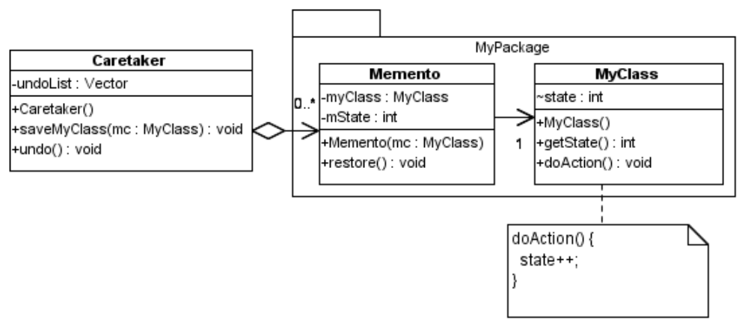
You may use the following Test Program to test the classes that you have implemented.

public class TestMemento {
public static void main(String args[]) {
Caretaker ct = new Caretaker();
MyClass mc = new MyClass();
System.out.println("Create a my class object with state 1");
System.out.println("Current state : " + mc.getState());
ct.saveMyClass(mc);
mc.doAction();
System.out.println("Change my class object to state 2");
System.out.println("Current state : " + mc.getState());
ct.saveMyClass(mc);
mc.doAction();
System.out.println("Change my class object to state 3");
System.out.println("Current state : " + mc.getState());
ct.saveMyClass(mc);
mc.doAction();
System.out.println("Change my class object to state 4");
System.out.println("Current state : " + mc.getState());
ct.undo();
System.out.println("Perform undo");
System.out.println("Current state : " + mc.getState());
ct.undo();
System.out.println("Perform undo");
System.out.println("Current state : " + mc.getState());
}
}
Sample output of the test program :-

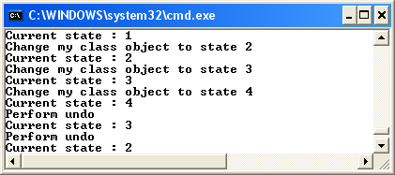

Part I B

Add one more Stack to the CareTaker with the name redoList.
Add one more method redo to the CareTaker. You should move CareTake to the same package of Memento.
Use following menu and corresponding output to perform redo undo, you are NOT required to use Command Pattern and Factory Pattern. Your program should create the object mc at the beginning.
Your Java program to contain main() method must be named as Lab06Q1B.java

Create a my class object with state 1
Enter command: 0 = exit, 1 = undo, 2 = redo, 3 = doAction
3
Current state :2
Enter command: 0 = exit, 1 = undo, 2 = redo, 3 = doAction
3
Current state :3
Enter command: 0 = exit, 1 = undo, 2 = redo, 3 = doAction
1
Perform undo.
Current state :2
Enter command: 0 = exit, 1 = undo, 2 = redo, 3 = doAction
1
Perform undo.
Current state :1
Enter command: 0 = exit, 1 = undo, 2 = redo, 3 = doAction
1
Nothing to undo.
Enter command: 0 = exit, 1 = undo, 2 = redo, 3 = doAction
2
Perform redo.
Current state :2
Enter command: 0 = exit, 1 = undo, 2 = redo, 3 = doAction
2
Current state :3
Enter command: 0 = exit, 1 = undo, 2 = redo, 3 = doAction
2
Nothing to redo.

Part II

Scenario : SuperBank Corporation

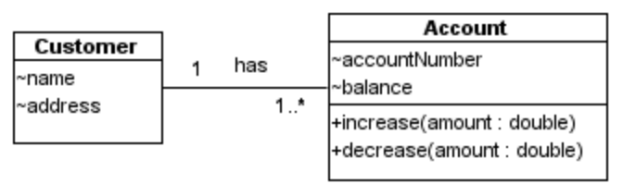
Figure 1: Class Diagram for a bank application of Superbank Corporation.

Because of the merger of the two organizations (BankOne and KWBank), the new corporation Superbank is now formed. For a particular application, if the transaction fails to save because of a dropped network connection or other reason, the system may reach an inconsistent state. You are asked to apply Memento pattern in order to restore the state of the system.

The Memento pattern provides a way to preserve the state of an object, while preserving encapsulation.

The requirement is to apply the Memento pattern to provide undo operations. The Memento object should be able to:
- save the state (e.g. balance) of an account object, or
- restore the state of an account object, or
- save the state of a Customer object, or
- restore the state of a Customer object.

The Caretaker contains an undo list, which consists of Memento objects. The Caretaker has the method undo(), which performs undo of the last operation, such as:
- increase the balance of an account, or
- decrease the balance of one account, or
- add an account to a customer, or
- remove an account from a customer.

Draw a design class diagram for the system. Implement the design class diagram of the system using Java.

Use following program to test your Memento:
import java.io.*;
import java.util.*;

public class Main {
public static void main(String args[]) {
Main driver = new Main();
driver.Start();
} // main

public void Start() {

// Peter has two accounts
Customer peter = new Customer("Peter", "Wanchai");
Account a1 = new Account("INT001", 100);
Account a2 = new Account("INT002", 200);
peter.addAccount(a1); peter.addAccount(a2);

// Prepare a Caretaker for the undo operation
Caretaker ct = new Caretaker();

// print out
System.out.println( "SuperBank Customer: " + peter.getName() + " "
+ "at address: " + peter.getAddress());
for (Enumeration xx = peter.getAllAccounts();
xx.hasMoreElements();) {
Account x = (Account)(xx.nextElement());
System.out.println("Account Number: " + x.getAccountNumber() + " "
+ "has balance " + x.getBalance());
} // for end

// Do some transaction
ct.saveAccount(peter.getAccount("INT001"));
peter.getAccount("INT001").increase(50);

ct.saveAccount(peter.getAccount("INT001"));
peter.getAccount("INT001").decrease(20);

ct.saveCustomer(peter, CustomerMemento.REMOVE_ACCOUNT, peter.getAccount("INT002"));
peter.removeAccount(peter.getAccount("INT002"));

// undo now
ct.undo();
ct.undo();
ct.undo();

// print out
System.out.println( "SuperBank Customer: " + peter.getName() + " "
+ "at address: " + peter.getAddress());
for (Enumeration xx = peter.getAllAccounts();
xx.hasMoreElements();) {
Account x = (Account)(xx.nextElement());
System.out.println("Account Number: " + x.getAccountNumber() + " "
+ "has balance " + x.getBalance());
} // for end

} // driver
} // Main Driver Program
Expected Output
Customer: Peter is created.
--- add account : INT001
--- add account : INT002
SuperBank Customer: Peter at address: Wanchai
Account Number: INT002 has balance 200.0
Account Number: INT001 has balance 100.0
--- account no: INT001 increase amount: 50.0
--- account no: INT001 decrease amount: 20.0
--- remove account : INT002
Undo - restore customer content:--- add account : INT002
Undo - restore account value:restore account no: INT001 balance 150.0
Undo - restore account value:restore account no: INT001 balance 100.0
SuperBank Customer: Peter at address: Wanchai
Account Number: INT002 has balance 200.0
Account Number: INT001 has balance 100.0

